Australian Church Women Inc.
ABN 68 539 329 715

WORLD COMMUNITY DAY
2020
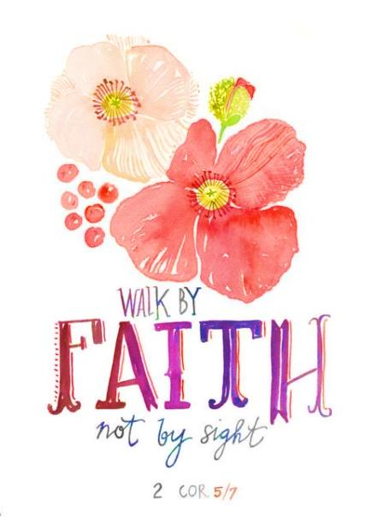

Moving Forward in Faith –
Daring to Risk

Australian Church Women Inc. (ACW Inc.)
Australian Church Women was established in 1965 when women’s inter-church councils from all states and territories came together to form Australian Church Women, fostering ecumenism and undertaking action on behalf of church women.
Australian Church Women seeks to unite Christian women across denominational boundaries to promote peace, understanding and unity through faith and love in the one God: Father, Son and Holy Spirit.

Fellowship of the Least Coin (FLC) Dedication
The setting aside of the least coin of one’s currency accompanied by prayers for justice, peace and reconciliation are brought together at this annual service of dedication. The funds are channelled to assist the education of those called by God to serve others both nationally and internationally.

General Offering
The General Offering supports the work of the Asian Church Women’s Conference (ACWC) and the ACW Inc. Special Project chosen for 2020, which is Sleepbus® Canberra for women. Sleepbus® provides a safe, temporary overnight accommodation service, getting people off the street by offering an immediate, first stop, cost-effective solution for our society’s most vulnerable; catching them early until they can get back on their feet.

Today’s Order of Service has been prepared by the New South Wales Unit of Australian Church Women with the theme for the current term being – Moving Forward in Faith. This service has the subtitle Daring to Risk.
Abbreviations: AHB – Australian Hymn Book. TiS – Together in Song.
SASB/TB – Salvation Army Song Book/Tune Book.

Please note: This Order of Service is copyright and may not be rewritten or altered, except for additional prayers where relevant in current situations.
The substitution of hymns may be considered to be more suitable to the local venue.

WELCOME
ACKNOWLEDGEMENT OF TRADITIONAL CUSTODIANS OF THE LAND
Call to Worship:
Leader: 'Faith is the assurance of things hoped for, the conviction of things not seen.'
Without faith it is impossible to please God.
All: For we live by faith, not by sight.
Leader: ‘Trust in the Lord with all your heart, and lean not on your own understanding; in all your ways submit to him, and he will make your paths straight.’
‘Be strong and courageous. Do not be frightened, and do not be dismayed, for the LORD your God is with you wherever you go.’
All: For God gave us a spirit not of fear but of power and love and self-control.
Leader: Like the Heroes of Faith may we dare to risk – Moving forward in faith!

Hymn: There’s a Light Upon the Mountains TiS 276, AHB 207
Prayers of Praise:
For that noble throng of saints of all ages and all lands who have stood steadfastly for the right against wrong
We praise you, O God
For the example of those willing to suffer that your truth may be preserved.
We praise, you, O God
For the courage of those who dare indifference to public opinion and step out in faith to declare your ways.
We praise you, O God
For your Holy Spirit Who strengthens and empowers our faith.
We praise you, O God
Hear our prayer, O God AMEN
3
Scriptures: Psalm 37:1‒6 (Good News)
Don’t be worried on account of the wicked; don’t be jealous of those who do wrong. They will soon disappear like grass that dries up; they will die like plants that wither. Trust in the Lord and do good; live in the land and be safe. Seek your happiness in the Lord, and he will give you your heart's desire. Give yourself to the Lord; trust in him, and he will help you; he will make your righteousness shine like the noonday sun.

Exodus 1:15‒16 prelude to reading of Exodus 2:1‒10
The king of Egypt told the midwives to kill Hebrew boys as soon as they were born. However they let the boys live, and when challenged as to why, replied that the Hebrew women gave birth before the midwives arrived. Then Pharaoh gave this order to all his people: “Every Hebrew boy that is born you must throw into the Nile, but let every girl live.”

Mark 5:25-34
Prayers of Petition:
Help us O God at all times to do the things we ought to do. May we have:
Clear vision,
To know what we have to do;
Courage,
To embark upon it, without fear
Skill,
To navigate your will;
Strength,
To resist temptations that distract us from your will;
Help us Lord, to faithfully fulfil all things in you.
AMEN

Hymn: God Moves in a Mysterious Way TIS 126, AHB 54
Message: Moving Forward in Faith – Daring to Risk
Prayers of Intercession:
O Lord, our God, we pray for those who minister in your name,
May they boldly speak your truth.
For those who have left home and loved ones to serve you in distant places,
Keep them safely in your care.
For all those who lobby for justice where injustice reigns,
Bless their efforts with success.
For those who risk their lives in service to our communities,
Empower them by your Spirit. AMEN

Item: Vocal or Instrumental
A Time of Reflection:
Leader: In the Fellowship Day service earlier this year we gave thanks for biblical characters who looked for God’s direction and made wise decisions.
Today we think of those who throughout the scriptures were used by God – people who were willing to move out of their comfort zone, willing to take risks. And we think of more contemporary risk takers who make a statement to better the lives of many in our world. Try to imagine yourself in the positions of the people we hear about now – could you trust God to help you bear the overwhelming challenges they faced or are facing?

Reader 1: Jochebed – Mother of Moses took the extraordinary step of putting her son in a waterproof basket in the Nile. He was found by Pharaoh’s daughter and raised as an Egyptian – but he later led the Israelites from Egypt.
Reader 2: Mary responded positively to the call to give birth to Jesus, and Joseph accepted the responsibility put on him. Both risked the flight into Egypt when boy children were being killed on Herod’s orders.

Reader 1: Joanna was wife to Chuza, Herod’s right-hand man, but she was devoted to supporting the ministry of Jesus ‘out of her own means’.

Reader 2: Sister Patricia Pak Poy was instrumental in the prohibition of the use of landmines. Born in Darwin of Chinese heritage, she became a Sister of Mercy, and in 1991 began a petition which culminated in the treaty to ban landmines.

Reader 1: Malala Yousafzai believed in the rights of education for girls and was shot by the Taliban. She dares to hope for interfaith harmony.

Reader 2: Greta Thunberg took action when she realised that lip service was achieving nothing for planet Earth with regard to climate change.

Prayer of Thanksgiving:
Loving God we give thanks for all who put their personal wellbeing at risk for what they see as the greater good. We pray that you will continue to raise up risk takers despite the apathy and hostility they must face in the modern world.
As we support the Fellowship of the Least Coin may we also strive for truth and justice so that the impoverished may be given the chance to rise above their poverty, and find meaningful employment to enrich their lives.

Fellowship of the Least Coin Dedication:
Provide a brief explanation of the FLC prayer movement.
See https://www.acw.org.au/the-fellowship-of-the-least-coin

Fellowship of the Least Coin Offerings:
Offerings brought forward and placed on an appropriately prepared display table as music plays. (Display FLC boxes, prayers, various least coins etc.)

Fellowship of the Least Coin Prayer Response:
Dear God, accept this least coin ‘Token of Love’. Make us mindful of the miracles of these coins. Let us honour your creation with love as shown through the life, death and resurrection of your Son, Jesus Christ. Amen

General Offering:
During the singing of the following hymn the General Offering will be received.
Hymn: Community of Christ TiS 473

Today’s General Offering will be equally divided between the Asian Church Women’s Conference and our Special Day Project (see inside cover).

Offertory Prayer:
All good gifts come from you, dear Lord, and from these riches we bring this offering. May it be used for the furtherance of your purposes, and for the benefit of those in need. Amen.

Hymn: God Gives us a Future TiS 687 Tune: At The Name of Jesus

Final Blessing:
Disturb us, Lord, to dare more boldly,
to venture on wider seas
where storms will show your mastery;
where losing sight of land,
we shall find the stars.
We ask you to push back
the horizons of our hopes;
and to push into the future
in strength, courage, hope and love.
AMEN
Attributed to Sir Francis Drake (1540–1596)
