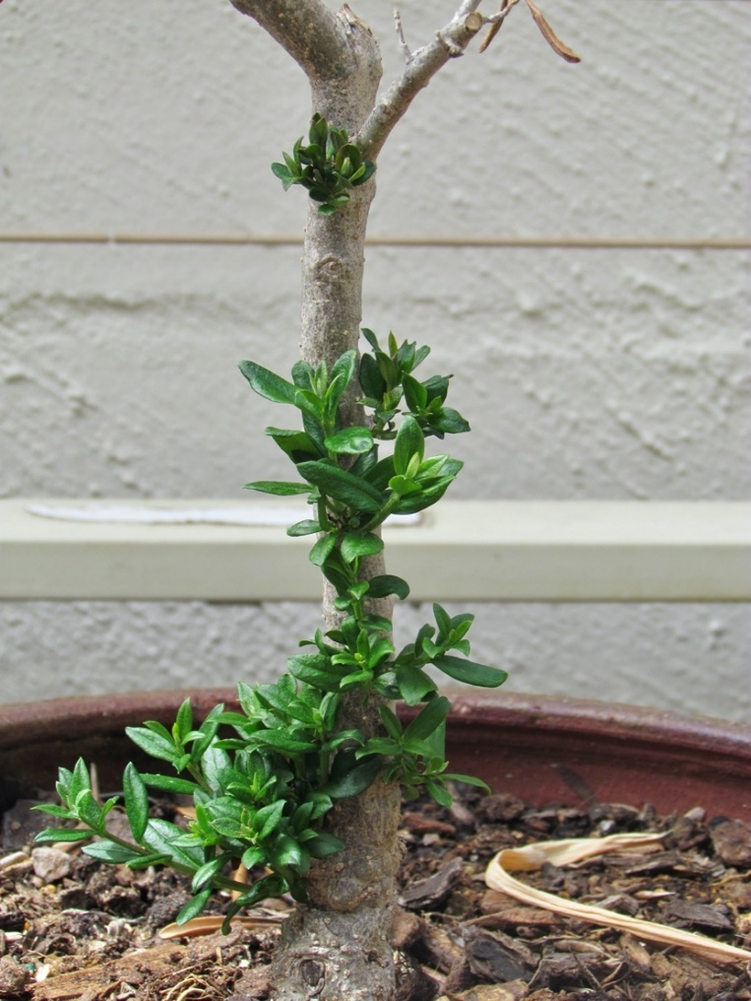
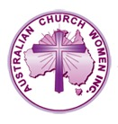
WORLD COMMUNITY DAY

2022

Renewal through Trust:

Caring brings Renewal
Australian Church Women Inc. ABN 68 539 329 715
AUSTRALIAN CHURCH WOMEN INC.
In 1965, women’s inter-church councils from all states and territories came together to form Australian Church Women.
Today Australian Church Women Inc is a network of committed Christian women dedicated to encouraging fellowship and service across denominational, national and international boundaries and promoting peace, understanding and unity through faith and love in the one God: Father, Son and Holy Spirit.
FELLOWSHIP OF THE LEAST COIN (FLC)
The setting aside of the least coin of one’s currency accompanied by praying for justice, peace and reconciliation are brought together at this annual service of dedication. The funds are channeled to the National Treasurer. These funds are allocated internationally.
GENERAL OFFERING
The general offering today supports the work of the Asian Church Women’s Conference (ACWC).

TODAY’S ORDER OF SERVICE was prepared by the Western Australian Unit of Australian Church Women.

PLEASE NOTE:
This order of service is copyright and may not be rewritten or otherwise altered except for additional prayers, where relevant for the current situation, and the substitution of hymns that are considered to be more suitable or available locally.

ABBREVIATIONS TiS Together in Song
NIV New International Version
CEV Contemporary English Version
The online Service will be available on 28 October at https://www.acw.org.au/

WELCOME

ACKNOWLEDGEMENT OF TRADITIONAL CUSTODIANS OF THE LAND

CALL TO WORSHIP PSALM 63:1–5 CEV

LEADER: You are my God. I worship you. In my heart I long for you, as I would long for a stream in a scorching desert.

RESPONSE: I have seen your power and your glory in the place of worship.

LEADER: Your love means more than life to me, and I praise you.

RESPONSE: As long as I live, I will pray to you. I will sing joyful praises and be filled with excitement like a guest at a banquet.

HYMN NOW THANK WE ALL OUR GOD TiS 106(i)

SCRIPTURE READINGS
Ephesians 1:15–19 NIV
Philippians 2:1–6 NIV
Luke 10:25–37 CEV
(After last reading)
READER: This is the word of the Lord.
ALL: Thanks be to God.

PRAYERS OF PRAISE AND PETITION
Father God, we thank you for your boundless and unceasing love and care for your children and for all people of every tribe and nation.

We thank you for Christians of all ages and all countries who have lived out their faith in you by loving care and concern for others.

We thank you for all who have cared for us and helped us to grow in our love and understanding of who you are and how we can serve you.

Father God, we ask that you help us to be more like Jesus. Fill us with your Holy Spirit. Help us to listen to you and follow your leadings. May we reach out in love to others, to listen, to encourage and to care.
Lord, hear our prayer through Christ Jesus. Amen

HYMN MAY THE MIND OF CHRIST MY SAVIOUR TiS 609

GUEST SPEAKER

FELLOWSHIP OF THE LEAST COIN DEDICATION
LEADER: We thank God that Shanti Solomon was inspired to begin the Fellowship of the Least Coin prayer movement. The prayers and coins offered have brought God’s love and care into many lives, bringing hope and renewal of opportunity to make a better life.

(For more information about the FLC prayer movement see www.acw.org.au and look under National on the menu.)

You are now invited to bring forward your FLC offerings and place them on the table provided as music is played.
(It may be helpful to have a display of FLC materials – boxes, prayers etc.)

Let us join together in the Fellowship of the Least Coin prayer.
O Loving Creator, we present ourselves in your divine presence to thank you for all the bountiful gifts of life. We are especially grateful for the Fellowship of the Least Coin, which binds us together in love and forgiveness around the globe. Free us from all doubts and prejudices, we pray. Inspire us to live in solidarity with humankind that we may know the joy of giving and receiving. Dear God, accept this least coin ‘token of love’. Make us mindful of the miracles of these coins. Let us honour your creation with love, as shown through the life, death, and resurrection of your Son, Jesus the Christ. Amen

PRAYERS OF INTERCESSION
Father God, we bring before you the people of the world.

Voice 1
WE PRAY FOR AFRICA
For the struggle for access to safe drinking water and irrigation for their crops. For projects to alleviate poverty. For aid from wealthier countries for protection against COVID. For freedom from tribal conflicts. For the rapidly growing number of vibrant Christians living out their faith.

ALL: Lord, hear our prayer.

Voice 2
WE PRAY FOR THE AMERICAS
For efforts to improve the lot of the oppressed and marginalized. For an ending to racial discrimination. For an end to the power of the gun. For respect and fairness and justice for all.

ALL: Lord, hear our prayer.

Voice 1
WE PRAY FOR ASIA
For an end to trafficking of women. For our sisters in the countries of the Asian Church Women’s Conference. For peace in Myanmar. For our prayer partner sisters in Japan who faithfully pray for Australia. For peace in all of Asia.

ALL: Lord, hear our prayer.
Voice 2
WE PRAY FOR EUROPE
For refugees from conflict. For the people of Ukraine and for all people supporting them. For wise decisions by leaders. For a growing faith in God.

ALL: Lord, hear our prayer.

Voice 1
WE PRAY FOR THE PACIFIC
For action to combat climate change. For the translation of the Bible into the languages of Papua New Guinea. For New Zealand and our own country Australia.

ALL: Lord, hear and answer our prayers.

HYMN IN CHRIST THERE IS NO EAST OR WEST TiS 459(ii)

The GENERAL OFFERING will be received whilst we sing, and it will go to support the work of the Asian Church Women’s Conference.

PRAYER
We thank you Lord for all your gifts. We bring our offering to you to be used to help and bless others in your name.

THE LORD’S PRAYER
Our Father in heaven, hallowed be your name. Your kingdom come, your will be done on earth as in heaven.
Give us this today our daily bread. Forgive us our sins, as we forgive those who sin against us.
Save us from trial. And deliver us from evil.
For the Kingdom, the power and the glory are yours now and forever. Amen

A TIME OF REFLECTION
Today we consider three Old Testament women who were prepared to move out of their comfort zones to care.

Ruth and Naomi were widows. When Naomi returned to her own country, Ruth, out of respect and love, went with her, prepared to take on the ways and God of a strange land. Naomi was grateful for Ruth’s support and worked to find a way they could live well in her homeland, Israel. Boaz became Ruth’s husband. Both women had a new life.

In 2 Kings, chapter 5, we read of a young girl from Israel who had been taken captive to Aram and had become a servant to Naaman’s wife. Naaman was Commander of the Army of the King of Aram, but he was a leper. The servant girl was brave enough to suggest that if Naaman saw the prophet (Elisha) in Samaria he could be cured.

May these stories encourage us in our caring.

HYMN THE KING OF LOVE MY SHEPHERD IS TiS 145

BLESSING

LEADER: May God bless you and keep you in his love.
May the Lord Jesus guide you, strengthen you and help you grow like him.
May the Holy Spirit work through you for the blessing of others.
Go in peace to love and serve the Lord.

ALL: We go in the name of Jesus.
Amen

