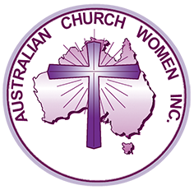

Australian Church Women Inc.
ABN 68 539 329 715

WORLD COMMUNITY DAY
2021
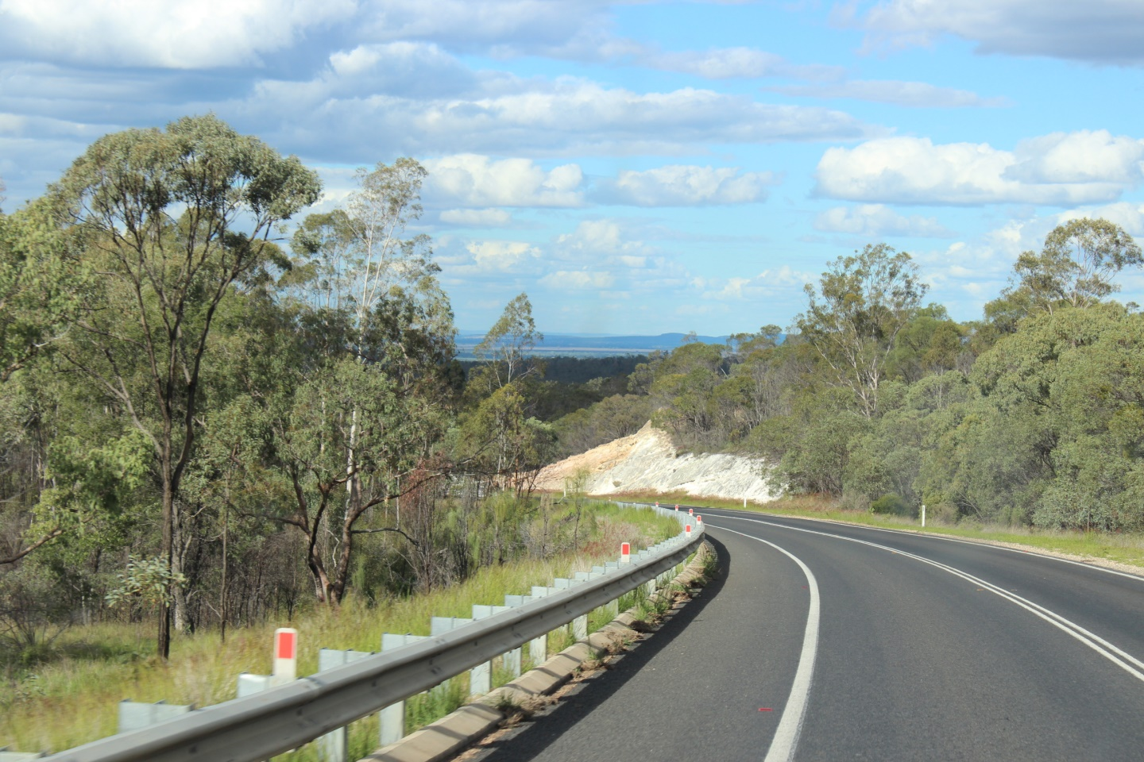
Photo by Rosemary Pitman - taken on the road between Mackay and Clermont, Queensland, 22 May 2019

Moving Forward in Faith –
Living a Powerful Life

Australian Church Women Inc. (ACW Inc.)
Australian Church Women was established in 1965 when women’s inter-church councils came together to form Australian Church Women, fostering ecumenism and undertaking action on behalf of church women.
Australian Church Women seeks to unite Christian women across denominational boundaries to promote peace, understanding and unity through faith and love in the one God: Father, Son and Holy Spirit.

Fellowship of the Least Coin (FLC) Dedication
The setting aside of the least coin of one’s currency accompanied by prayers for justice, peace and reconciliation are brought together at this annual service of dedication. The funds are channelled to assist the education of those called by God to serve others both nationally and internationally.

General Offering
The general offering supports the work of the Asian Church Women’s Conference (ACWC) and the ACW Inc. Special Project chosen for 2021–22, which is Kick Start Your Life, run by WA Mums Cottage Inc. It has both formal and informal aims to create adaptive and positive behaviours in a two-hour session one morning a week for ten weeks. The WA Mums Cottage is a drop-in centre for women and children suffering distress in the domestic environment. Its ethos is Christian service to those in need and has the support of local churches. It is run by a committed team.
This Order of Service has been prepared by the South Australian Unit of Australian Church Women with the theme for the current term being – Moving Forward in Faith. This service has the sub-title Living a Powerful Life.
Abbreviations: AHB – Australian Hymn Book, TiS – Together in Song,
SASB/TB – Salvation Army Song Book/Tune Book.
Please note:
This Order of Service is adapted for the online service at https://www.acw.org.au/
and is copyright. It may not be re-written or altered, except for additional prayers where relevant in current situations. The substitution of hymns may be considered to be more suitable to the local venue.

Resources on our ACW website are available at
https://www.acw.org.au/the-fellowship-of-the-least-coin

WELCOME
ACKNOWLEDGEMENT OF TRADITIONAL CUSTODIANS OF THE LAND
Call to Worship:
Leader: As we gather within this community of faith, we are fed.
All: Praise, thanks, prayer and God’s Word feed our minds and spirits.
Leader: The teachings of Jesus bring us to the faithful way.
All: The cross of Jesus calls us to the selfless, practical way.
Leader: The rising of Jesus from death, fills us with a timeless, unbounded hope.
All: We are graciously fed.
Guide us as we speak, and when we listen. In all our talking, our thinking, our planning and our deciding, may we discern your will more clearly. May we work towards your purpose for us, so that our hearts will be open to one another, with compassion and consideration. When we meet together, you are always among us. Meet with us now as we offer this day to your glory. Amen
Psalm 92:1–4 (NIV)
It is good to praise the Lord and make music to your name O Most High, proclaiming your love in the morning and your faithfulness at night, to the music of the ten-stringed lyre and the melody of the harp. For you make me glad by your deeds, LORD. I sing for joy at what your hands have done.
We sing our praise to God.
Hymn: All people that on earth do dwell Tis 59
Prayers of Praise:
Leader: We praise you Father God for your enduring faithfulness, forgiveness and compassionate heart.
All: We walk by faith not by sight.
Leader Your gracious everlasting faithfulness defies description. Your merciful forgiveness accepts us as we are.
All: We walk by faith not by sight.
Leader: The wonder of your handiwork overwhelms us. You are worthy God, of our praise and adoration.
All: We walk by faith not by sight.
Leader: We acknowledge your Sovereignty. We thank you that you know what is best for us. Our needs are always met in you.
All: We walk by faith not by sight.
Leader: We live in a world largely unrepentant. Teach us to stand firm and rely on our Lord Jesus who is the Cornerstone of our faith.
All: We walk by faith not by sight.
Leader: Lord God, may our praise and thanksgiving be evident as we walk in the way of your righteousness. May the transformation of your Glory magnify our hope in you.
All: We walk by faith not by sight.
Leader: Let all who seek you rejoice and be glad. May we consistently say 'how great and glorious is our God.'
All: We lift our voices in praise. 'Ascribe to the Lord the glory due to his name.' We bless your Holy Name.
Leader: We celebrate the gift of mustard seed faith! Enlarge our trust in you and grant us Lord God the ability to move forward as we ….....................................
All: Lift our voices in praise. 'Ascribe to the Lord the Glory due to his name.' We bless your Holy Name.
Scriptures: Matthew 15:21–28 (NIV)
Leaving that place, Jesus withdrew to the region of Tyre and Sidon. A Canaanite woman from that vicinity came to him, crying out, “Lord, Son of David, have mercy on me! My daughter is demon-possessed and suffering terribly.”
Jesus did not answer a word. So his disciples came to him and
urged him, “Send her away, for she keeps crying out after us.”
He answered, “I was sent only to the lost sheep of Israel.”
The woman came and knelt before him. “Lord, help me!” she said.
He replied, “It is not right to take the children’s bread and toss it to the dogs.”
“Yes it is, Lord,” she said. “Even the dogs eat the crumbs that fall from their master’s table.”
Then Jesus said to her, “Woman, you have great faith! Your request is granted.” And her daughter was healed at that moment.
Fellowship of the Least Coin Dedication
An excellent video introduction to the Fellowship of the Least Coin was produced by the Women's Inter-Church Council of Canada in October 2018, and it is available at https://www.youtube.com/watch?v=3tYomxrkqeg
Fellowship of the Least Coin Offerings
If you are unable to present your FLC offering at this time, please set it aside until you can meet with other FLC supporters or contact your state or territory ACW Unit to arrange the collection of your offering.
Fellowship of the Least Coin Prayer Response:
The spirit in which we offer our gifts to God is the spirit of thanksgiving for all God has given us.
The spirit in which we offer our gifts to God is the spirit of sharing from our plenty, with those who need compassion and care around our world, through the Fellowship of the Least Coin and our special project.
We rejoice in the gift of Jesus Christ and seek to follow him faithfully.
Gracious God accept our gifts for your blessing in the name of Jesus. Amen
Hymn: Count your Blessings /When Upon Life’s Billows
SASB/TB 396/202
Prayers for Others:
Leader: ‘Trust in the Lord with all your heart, and do not rely on your own insight. In all your ways acknowledge him, and he will make straight your paths.’ Proverbs 3:5–6
Lord, you have been a refuge to the poor, the needy and all in distress.
All: Give us the insight and strength to support all in need.
Leader: You protect orphans and widows and shelter the desolate.
All: Dear Lord, strengthen and encourage them.
Leader: Send your spirit of justice and peace into the hearts of all Governments and Leaders.
All: That all may live without fear of harm and oppression.
Leader: We pray for doctors and nurses and for all who show your love by their care and service, and we give thanks for their dedication and care. Support those who struggle to heal all affected by the COVID-19 virus and combat the spread of the pandemic.
All: Increase our compassion for the needs of all we meet in our daily journey.
Leader: May your healing grace and love be with those who are terminally ill, and for whom there is no quality of life, or who feel alone in the world.
All: Show us ways to increase our love, support and understanding.
Leader: We pray for FLC projects around the world, and the provision of resources for sustainable life. Encourage and support your people to share the wealth and beauty of their lands.
All: That all may live to know your wonderful bounty of love and worship you in faith and hope.
Leader: Heavenly Father, as we pray for one another, fill us with the power of your Spirit, that in all we do and say, we may reflect your love.
All: By proclaiming the Good News of your Kingdom in our Community, and to the peoples of the world:
We ask in the name of Jesus Christ, our Lord and Saviour.
Amen
All: The Lord’s Prayer
Our Father in heaven,
hallowed be your name
your kingdom come,
your will be done,
on earth as in heaven.
Give us today our daily bread.
Forgive us our sins
as we forgive those who sin against us.
Save us from the time of trial
and deliver us from evil.
For the Kingdom, the power and the glory are yours
now and forever. Amen
Hymn: When I needed a Neighbour TiS 629
General Offering Dedication
If you are unable to present your offering at this time, please set it aside until you can meet with other supporters of ACW's Special Project or contact your state or territory ACW Unit to arrange the collection of your offering.
General Offering
The General Offering will be received during the singing of the following hymn.
Hymn Have Faith in God Praise and Worship 714
Geoff Bullock
Blessing We are a pilgrim people moving forward in faith.
The Kingdom of God is here, in our midst, in this place.
With us, in us, through us, God is making all things new.
We are all God’s beloved.
God’s Love is something which must be shared.
With joy live fully into the future with God the Father, the Son and the Holy Spirit. Amen

